Sandra Orchard (V2 03/10/12)

A tour of proteomic resources

UniProt – the protein sequence database

www.uniprot.org

UniProt (Universal Protein Resource) is the world's most comprehensive catalogue of information on proteins. It is a central repository of protein sequence and function. The UniProt Knowledgebase (UniProtKB) is the central access point for extensive curated protein information, including function, classification, and cross-reference. The database is divided into two section UniProtKB/SwissProt which is manually curated and UniProtKB/TrEMBL which is automatically maintained. During this course you will concentrate on UniProtKB/SwissProt and learn how to access the entries in the database, extract the maximum amount of information from them.

BLAST (Basic Local Alignment Search Tool), finds regions of sequence similarity and gives functional and evolutionary clues about the structure and function of your novel sequence.

For this exercise, we will use the BLAST program on the UniProt website, which allows you to restrict your search by taxonomic group.

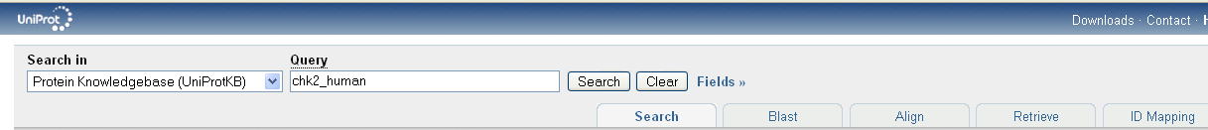

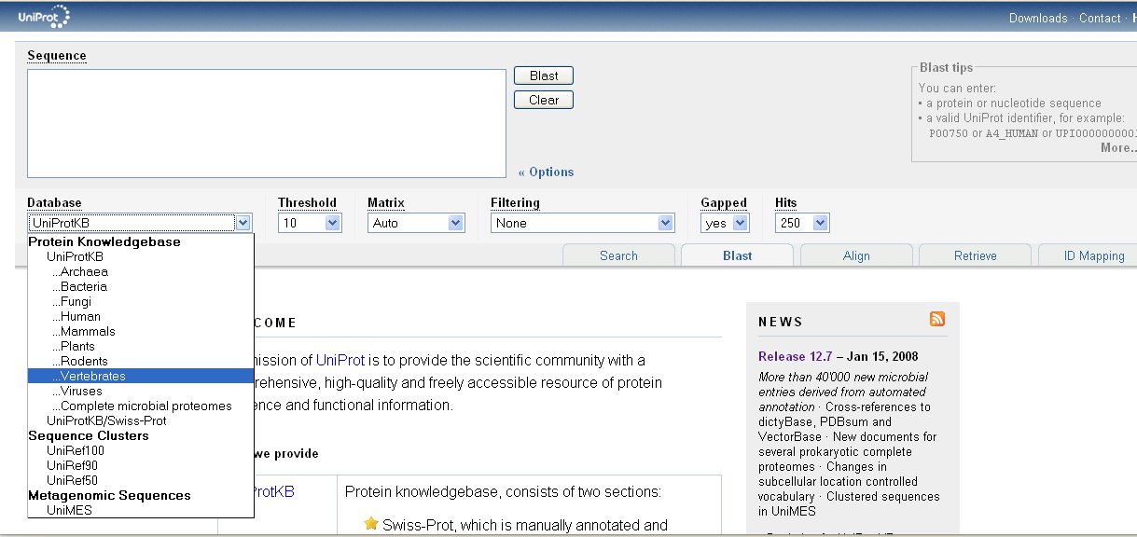

Exercise 1 – Exploring UniProtKB
 Go to the BLAST tool on the UniProt.org website. Paste in the Mystery protein sequence below. Restrict the search to Vertebrates.

Mystery Protein sequence
MSRESDVEAQQSHGSSACSQPHGSVTQSQGSSSQSQGISSSSTSTMPNSSQSSHSSSGTL
SSLETVSTQELYSIPEDQEPEDQEPEEPTPAPWARLWALQDGFANLECVNDNYWFGRDKS
CEYCFDEPLLKRTDKYRTYSKKHFRIFREVGPKNSYIAYIEDHSGNGTFVNTELVGKGKR
RPLNNNSEIALSLSRNKVFVFFDLTVDDQSVYPKALRDEYIMSKTLGSGACGEVKLAFER
KTCKKVAIKIISKRKFAIGSAREADPALNVETEIEILKKLNHPCIIKIKNFFDAEDYYIV
LELMEGGELFDKVVGNKRLKEATCKLYFYQMLLAVQYLHENGIIHRDLKPENVLLSSQEE
DCLIKITDFGHSKILGETSLMRTLCGTPTYLAPEVLVSVGTAGYNRAVDCWSLGVILFIC
LSGYPPFSEHRTQVSLKDQITSGKYNFIPEVWAEVSEKALDLVKKLLVVDPKARFTTEEA
LRHPWLQDEDMKRKFQDLLSEENESTALPQVLAQPSTSRKRPREGEAEGAETTKRPAVCA
AVL

The resulting scores should suggest a 100% match to CHK2_HUMAN (O96017). You should also note a match to the isoforms of CHK2 – each isoform is treated as a separate transcript, information which is often lost when using other protein sequence databases.

Click on the top green bar in the Local Alignment column to display the aligned sequences.

The UniProt Consortium is comprised of the European Bioinformatics Institute, the Swiss Institute of Bioinformatics and the Protein Information Resource. The UniProt consortium aims to support biological research by maintaining a high quality database that serves as a stable, comprehensive, fully classified, richly and accurately annotated protein sequence knowledgebase, with extensive cross-references and querying interfaces freely accessible to the scientific community.

All data stored in UniProt can be downloaded from the Download Centre at http://www.ebi.uniprot.org/database/download.shtml

Return to the search page and open O96017/CHK2_HUMAN.

Click on the EC number link under protein names.

 Q 1. What is the reaction catalysed by this enzyme?

Return to the entry and go to the Alternative Products section.

Chek2 is a protein for which multiple (12) isoforms have been identified. All of these are mapped within UniProtKB, and given stable identifiers.

Press the button “Align” to see how all the isoforms differ.

Return to the Alternative Products section.

Q 2. What functional characteristic has the alternative splicing has conferred to isoform 12 (and other isoforms)?

To see the location and length of the missing region in isoform 12 go the UniProt entry (click O96017) and look in the Sequence annotation section under Natural variations.

Q 3. Using the information in the table, explain why isoform 12 is catalytically inactive?
(Hint – where’s the active site.)

Q 4. Where in the cell is isoform 12 to be found?
(Hint – look in Comments –> Subcellular location)

Q 5. What is the length of isoform 12?

Now move to the Sequence Annotation table

Q 6. What information can you gather about residue 347 (amino acid type, role in enzyme, variant effect, mutagen effect)

The IntAct Molecular Interaction database - exploring the Interaction Space

Q 7. How many evidences are there of an interaction between CHK2 and PLK1.

Click on the link to open the entry in the IntAct database.

Q 8. What method has the example on which this search has opened, has the interaction been identified by?

Expand the search by opening the List tab. Select both CHK2 and PLK1 and Search Interactions (note – intact defaults on an ‘OR’ search rather than ‘AND’ to enable this).

Look at the results in the Graph Tab.

Q 9. The PLK1 and CHK2 clusters have two proteins they both interact with – which proteins are these?

Open the Search Tab. This panel is specialised to give you an easy access to ontology search. So far you can search on 4 ontologies:
Gene Ontology
InterPro
PSI-MI
ChEBI
Type: mitosis in the Ontology Search box.
You will be presented with a few choices, please note that each term is followed by the count of matching interactions in the IntAct database.
Select the parent term ‘mitosis’ (GO:0007067) using the keyboard cursor keys, complete the search and you will be taken to the interaction tab. This now gives you ALL the interactions for proteins in IntAct which GO have annotated as being involved in the process of mitotis. Add the term ‘AND species: human’ to limit this to interactions in which one of the interactors is of human origin.

Tissue expression data - PRIDE

Find and open the cross-reference to the PRIDE database.
List 3 tissue and 3 cell types CHK2 is found in. Are any of these also present in the literature curated Tissue Specificity comment in the UniProt entry?

Putting proteins into pathways using Reactome

Find and open the cross-reference to the Reactome database. Open Cell cycle → Cell cycle check points on the pathways browser. Click on  to open the Search diagram facility and look for CHEK2.
Q 9. Which protein is shown as activating CHEK2 (hint look under tab “Processes” if you cannot tell this from the graph)

Searching UniProtKB

Return to the search engine at the top of the entry page and click on Fields

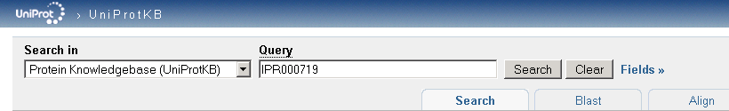

Use the fields to search on IPR000719 AND Organism=human to see how many protein kinases you can find.

Q 9. How many of those are in Swiss-Prot (i.e. reviewed records)?

Q 10. Furthermore, how many of those have experimental evidence of being associated with the cell membrane?
(As well the subcellular location fields in the Comments section other fields such keywords and gene ontology also have subcellular location information. However, in the UniProt search facility only the subcellular location fields allows the evidence to taken in to account.)

If time permits, return to UniProt to investigate the 3D structure of the protein using links to PDB, and known inhibitors of CHEK2, using links to ChEMBL.

Further Reading

- The UniProt Consortium “Activities at the Universal Protein Resource (UniProt)..” Nucleic Acids Res. (2014) 42:191-198

- Hunter S et al “InterPro in 2011: new developments in the family and domain prediction database” Nucleic Acids Res. (2012) 40:306-312

- Orchard S et al “The MIntAct project--IntAct as a common curation platform for 11 molecular interaction databases.” Nucleic Acids Res. (2014)42:358-363

- Croft, D., et al. 2014 “The Reactome pathway knowledgebase” Nucleic Acids Res. (2014)42:472-477

- Vizcaíno JA., et al. “The PRoteomics IDEntifications (PRIDE) database and associated tools: status in 2013.” Nucleic Acids Res 2013, 41:1063-9

